Implementing Gated Recurrent Units on FPGAs: A Literature Review for Brain-Computer Interface Applications with Hardware-Specific Optimizations

Contents
Introduction 2
Basic Architecture of a Brain-Computer Interface (BCI) System 2
Gated Recurrent Unit (GRU) 3
Field-Programmable Gate Array (FPGA) 5
GRUs: Theory and Functionality 6
GRUs and BCI 6
Gated Recurrent Units (GRUs) 7
Hardware Acceleration of GRUs 9
Current GRU Implementations on FPGAs 9
Optimization Techniques 11
Shift-And-Add Multiplication 12
Bit Serial Structures 13
Distributed Arithmetic 14
Mixed Precision 14
Critical Analysis and Research Gaps 16
Conclusion 17
References 17

Introduction
The objective of this review is to examine the current state of research on deploying Gated Recurrent Units (GRUs) on Field-Programmable Gate Arrays (FPGAs), specifically in the context of Brain-Computer Interface (BCI) applications.
The scope of this review includes background on BCI, GRUs, and FPGAs, why GRUs are used for BCI, how GRUs work, FPGA-specific optimizations that can be applied to algorithms, and a critical analysis of the current research and gaps.

Basic Architecture of a Brain-Computer Interface (BCI) System
Brain-Computer Interfaces (BCIs) are a machine learning based system that can recognize and classify brainwaves. They tend to follow five consecutive stages: signal acquisition, preprocessing / signal enhancement, feature extraction, feature classification, and device control [1].
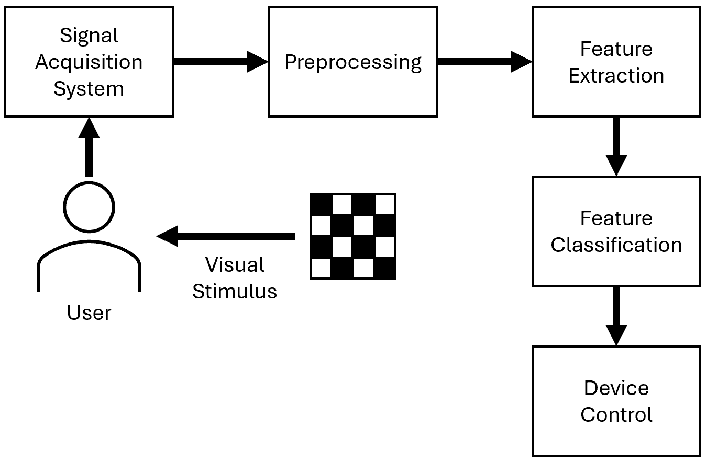
Fig. 1. Basic architecture of a BCI system
Signal Acquisition: Captures brain activity and may also perform noise reduction or artifact processing. This is often done via non-invasive electroencephalography (EEG) by putting electrodes on the scalp to gather electrical signals.
Preprocessing / Signal Enhancement: Prepares the signal in a suitable form for further processing to maximize the signal-to-noise ratio. Noise is caused by nonneural sources (e.g., 60-Hz line noise and eye movements) and neural sources (e.g., EEG features other than those used for communication).
Feature Extraction: Extract parts of the signal that contain discriminative information.
Feature Classification: Convert the extracted feature into a predetermined classification. There is diversity in classification algorithms due to the diversity of BCIs’ intended real-world applications, and classification algorithms are specialized to their intended use case [2].
Device Control: Translate the classified signal into a meaningful output, such as driving a wheelchair.

Gated Recurrent Unit (GRU)
Machine learning can be used to perform feature extraction and classification from BCI signals [2]. Due to BCI signals being time-dependent, a machine learning algorithm that can do temporal modeling is required. Feedforward neural networks (FNNs) can struggle with this due to them treating inputs independently [3]. To deal with this, Jordan et al. developed recurrent neural networks (RNNs), which are designed to do temporal modeling. Unlike Feedforward Neural Networks (FNNs), where each node passes information only to the next layer, RNNs also feed information back into previous nodes, allowing them to capture and retain temporal dependencies [4]. However, simple RNNs suffer from vanishing and exploding gradient problems, making them struggle to learn long-term dependencies [5]. To address this, Hochreiter et al. proposed Long Short-Term Memory (LSTM) units. LSTMs use gates to selectively retain, update, and output information, solving the vanishing gradient problem while still allowing temporal dependencies to be learned [6].
Gated Recurrent Units (GRUs) are a type of hidden unit used in recurrent neural networks, proposed in 2014 by Cho et al. They are similar to LSTM units but are computationally simpler and more efficient. This is because GRU’s only use two gates, a reset gate and an update gate, to control information flow through the hidden state. The reset gate allows the unit to drop any irrelevant information, allowing a compact representation of important previous state information. The update gate controls how much information from the previous hidden state is carried over to the current hidden state. These two states allow GRUs to capture dependencies over multiple time scales [7].
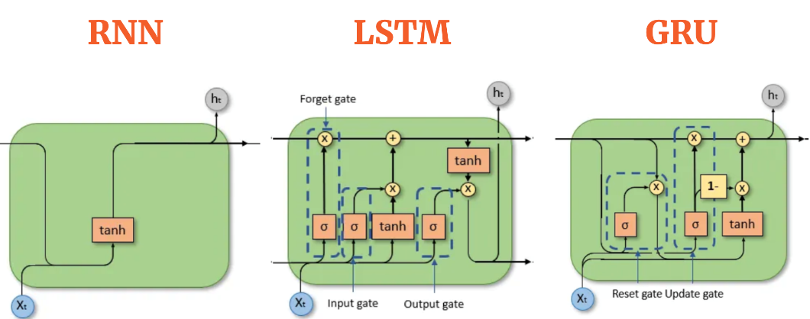
Fig. 2. Diagrams of different sequence models: RNN, LSTM, GRU [8].
Chung et al. demonstrated that GRUs and LSTMs achieve comparable performance on multiple data sets [9]. As shown in Table 1, Chung et al. evaluated hyperbolic tangent (tanh), GRU, and LSTM-based RNNs using four polyphonic music datasets and two Ubisoft speech signal datasets. Based on the inference metric negative log-probability, a metric used to quantify the uncertainty and confidence of predictions to determine how well a model fits the data [10], GRUs achieved the best performance in four datasets and performed comparably to the other models in the remaining two datasets [9].
Table 1
The average negative log-probabilities of the training and tests [9]
 |  |  | tanh | GRU | LSTM
Music Datasets | Nottingham | Train | 3.22 | 2.79 | 3.08
Music Datasets | Nottingham | Test | 3.13 | 3.23 | 3.20
Music Datasets | JSB Chorales | Train | 8.82 | 6.94 | 8.15
Music Datasets | JSB Chorales | Test | 9.10 | 8.54 | 8.67
Music Datasets | MuseData | Train | 5.64 | 5.06 | 5.18
Music Datasets | MuseData | Test | 6.23 | 5.99 | 6.23
Music Datasets | Piano-midi | Train | 5.64 | 4.93 | 6.49
Music Datasets | Piano-midi | Test | 9.03 | 8.82 | 9.03
Ubisoft Datasets | Ubisoft dataset A | Train | 6.29 | 2.31 | 1.44
Ubisoft Datasets | Ubisoft dataset A | Test | 6.44 | 3.59 | 2.70
Ubisoft Datasets | Ubisoft dataset B | Train | 7.61 | 0.38 | 0.80
Ubisoft Datasets | Ubisoft dataset B | Test | 7.62 | 0.88 | 1.26

Despite similar performance, GRUs have a smaller design architecture and fewer computations, shown in Fig. 2. This allows them to be easier to implement in hardware than an LSTM. However, the first hardware implementation of a GRU was not presented until 2021 by Zaghloul et al. [11]
Table 2
Resource Utilization on GRU Hardware Implementation [11]
Logic Component | GRU | LSTM
# BUFs | 3 | 6
# DSPs | 26 | 45
# Block RAM | 14 | 23
Memory LUTs | 342 | 496
FF | 10 241 | 16 025
# Slice Registers | 8 507 | 15 951
# Slice LUTs | 5 926 | 9 158

As shown in Table 2, Zaghloul et al.’s hardware implementation of a GRU compared to an LSTM used 50% less Buffers (BUFs), 42% less Digital Signal Processors (DSPs), 39% less Block Random Access Memory (Block RAM), 31% less Memory Look-Up Tables (Memory LUTs), 36% less Flip-Flops (FFs), 47% less Slice Registers, and 35% less Slice Look-Up Tables (Slice LUTs).
Table 3
Comparison Implementation Using Altera Arria 10GX FPGA [11]
Metric | GRU | LSTM
Performance per Watt | 157.39 | 146.62
Execution Time | 0.879 | 0.927

Despite GRUs having a smaller hardware footprint than LSTMs, Zaghloul et al. also found that the GRU had a higher inference performance per watt and lower execution time, as shown in Table 3.

Field-Programmable Gate Array (FPGA)
BCI systems require a computational unit to execute signal preprocessing, feature extraction, and classification in real time. Since brain signals are noisy, low-amplitude, and time-dependent, this unit must handle both numerical intensity and strict latency constraints. The most commonly considered platforms, Central Processing Units (CPUs), Graphic Processing Unit (GPUs), and Field-Programmable Gate Arrays (FPGAs) are summarized in Table 4.
Table 4
Pros and Cons of Common BCI Platforms [12-14]
Platform | Pros | Cons
CPU | Flexible, can handle diverse computing tasks.  Widely available and easy to program.  Mature software ecosystem. | High power consumption, critical for embedded systems.  Not fully optimized for ML operations (matrix additions/multiplications).  Lower parallelism.
GPU | Optimized for matrix operations.  High parallelism.  Tools like CUDA enable hardware-specific acceleration.  Well-suited for ML training and inference. | Higher power consumption than CPUs in embedded scenarios/  Memory constraints may require model optimization.  Bulkier and less portable than low-power solutions.
FPGA | Reconfigurable hardware allows custom accelerators.  High parallelism.  High performance and power efficiency for specific models.  Can be optimized at the model level. | Long development time.  High design costs for configuring programmable logic.  Requires specialized hardware design knowledge.

FPGAs are well-suited for BCI systems because their reconfigurability allows for flexible deployment and updating of different BCI machine learning models, while their high performance and low power consumption make them ideal for edge deployment close to users. Although they are more complex to program than CPUs or GPUs, continued research into FPGA-based BCI solutions can help overcome this issue.
An FPGA is a type of integrated circuit that can perform digital logic and algorithms. It contains reprogrammable configurable logic blocks and, unlike Application Specific Integrated Circuits (ASICs) that perform a single function, FPGAs can be reprogrammed to perform different algorithms. FPGAs have several upsides. Their ability to be reprogrammed allows for flexibility in their application. Further, FPGAs can often offer a large performance boost to algorithms compared to software implementations, especially for algorithms with integer or fixed-point data with a high degree of parallelism. Finally, FPGAs have a lower development cost than ASICs while providing similar functionality at a lower speed. However, FPGAs also have downsides. Their flexibility also increases the complexity of programming it, which must be weighed against potential algorithm speed improvements. Due to FPGAs implementing digital logic, they struggle with floating-point intensive applications due to the large amount of logic required for dealing with floating-point arithmetic. FPGAs will also not offer a large amount of speed gain for heavily sequential algorithms. Finally, FPGAs have a high barrier to use properly due to their complexity, resulting in hardware designers needing a significant amount of knowledge and experience in digital circuit design to get the most out of FPGAs [15].
Due to FPGAs being able to process the large amount of data that BCI outputs more efficiently than software-based systems, they seem well positioned to assist BCI systems [16-17]. In 2021, Cai et al. implemented an epilepsy detection algorithm on an FPGA, which improved classification performance and reduced power consumption compared to software implementations of the algorithm. As shown in Table 5, Cai et al. found that FPGA based BCI tended to have a higher accuracy than software-based implementations. This shows how FPGA deployment of algorithms can be more efficient compared to their software counterparts [18].
Table 5
Comparison of BCI Deployments Related to Cai et al.’s Deployment [18]
Reference | Processer | Accuracy (%)
Güneysu et al. [19] | CPU | 75
Martišius and Damaševičius [20] | CPU | 80.5
Chen et al. [21] | CPU | 83.3
Shyu et al. [16] | FPGA | 89
Lin et al. [22] | FPGA | 91
Cai et al. [18] | FPGA | 94.4

Moreover, FPGAs are being used increasingly in BCI due to their high speed, reliability, and integration [23].

GRUs: Theory and Functionality

GRUs and BCI
EEG signals used in BCI are often lengthy, one-dimensional, complicated, and nonlinear time sequence signals. Due to these signal characteristics, RNNs are often used to model this data. However, due to gradient explosion or gradient disappearance that RNNs can be prone to, LSTMs or GRUs are preferred compared to RNNs [24]. Rivas et al. compared GRUs and LSTMs and found their performance is comparable over several evaluation metrics, Root Mean Square Error (RMSE), Mean Square Error (MSE), Mean Average Error (MAE), and Symmetric Mean Absolute Percentage Error (SMAPE), thus both architectures can predict and classify EEG signals to reasonable accuracy. It was found that GRUs are more computationally efficient compared to LSTMs due to their smaller architecture. However, GRUs have a smaller memory capacity compared to LSTMs, leading them to struggle with long-term information, and they can struggle to generalize in some cases [25].
Table 6
Comparison of Different Evaluation Metrics [26-28]
Evaluation  Metric | Definition | Strengths
MSE | $$MSE=\frac{1}{n}\sum_{i=1}^{n}{{\left(y_{i}-{\hat{y}}_{i}\right)}^{2}}$$ | More sensitive to outliers than MAE/SMAPE because it penalizes large errors quadratically.  Great when large deviations are especially undesirable.
RMSE | $$RMSE=\sqrt{\frac{1}{n}\sum_{i=1}^{n}{{\left(y_{i}-{\hat{y}}_{i}\right)}^{2}}}$$ | More interpretable than MSE because it is in the same units as the target variable.  Same other strengths as MSE.
MAE | $$MAE=\frac{1}{n}\sum_{i=1}^{n}{\left|y_{i}-{\hat{y}}_{i}\right|}$$ | More robust to outliers than MSE/RMSE because it penalizes errors linearly.  Better reflects median performance than extreme cases.
SMAPE | $$SMAPE=\frac{100\%}{n}\sum_{i=1}^{n}{\frac{\left|y_{i}-{\hat{y}}_{i}\right|}{\left(\left|y_{i}\right|+\left|{\hat{y}}_{i}\right|\right)*0.5}}$$ | Expresses errors as percentages, allowing comparison across datasets with different scales.  Same other strengths as MAE.

Furizal et al. conducted a literature review on LSTMs and GRUs on time series data, specifically temperature forecasting, to determine their performance, summarized in Table 7 [29].
Table 7
LSTMs vs GRUs [29]
 | LSTM | GRU
Strengths | Better captures long-term dependencies and complex dynamics | Greater consistency and lower average RMSE, stronger prediction accuracy
Limitations | Performance may decline with time or specific datasets | Smaller memory capacity may limit very long-term dependencies
Conclusion | Popular and widely used, good performance but less stable across datasets | Often outperforms LSTM in accuracy consistency, more stable error distribution

Gated Recurrent Units (GRUs)
The original implementation of GRUs was done by calculating the following four functions for each layer [9]:
$$r_{t}=σ\left(W_{r}x_{t}+U_{r}h_{t-1}\right) \\ {\tilde{h}}_{t}=\tanh\left(Wx_{t}+U\left(r_{t}⊙h_{t-1}\right)\right) \\ z_{t}=σ\left(W_{z}x_{t}+U_{z}h_{t-1}\right) \\ h_{t}=\left(1-z_{t}\right)⊙h_{t-1}+z_{t}⊙{\tilde{h}}_{t}$$
Where:
- $r_{t}$: Reset gate.
- ${\tilde{h}}_{t}$: Candidate hidden state.
- $z_{t}$: Update gate.
- $h_{t}$: Hidden state.
- $⊙$ denotes the Hadamard product.

In modern implementations, GRUs are calculated using the following functions [30-31]:
$$r_{t}=σ\left(W_{ir}x_{t}+b_{ir}+W_{hr}h_{t-1}+b_{hr}\right) \\ n_{t}=\tanh\left(W_{in}x_{t}+b_{in}+r_{t}⊙\left(W_{hn}h_{t-1}+b_{hn}\right)\right) \\ z_{t}=σ\left(W_{iz}x_{t}+b_{iz}+W_{hz}h_{t-1}+b_{hz}\right) \\ h_{t}=\left(1-z_{t}\right)⊙n_{t}+z_{t}⊙h_{t-1}$$
Where:
- Inputs:
  - $d∈N$: Input feature dimension.
  - $h∈N$: Number of hidden units.
  - $t∈N$: Current timestep.
  - $n∈N$: Batch size (often $n=1$in deployment).
  - $x_{t}∈R^{d}$: Input vector at timestep $t$.
- Gates and States:
  - $r_{t}∈R^{h}$ Reset gate at timestep $t$.
  - $z_{t}∈R^{h}$: Update gate at timestep $t$.
  - $n_{t}∈R^{h}$: Candidate (new) hidden state at timestep $t$.
  - $h_{t}∈R^{h}$: Final hidden state at timestep $t$.
  - $h_{t-1}∈R^{h}$: Previous hidden state at timestep $t-1$.
- Operations:
  - $⊙$ denotes the Hadamard product.
  - $σ$ denotes the sigmoid function.
  - $tanh$ denotes the hyperbolic tangent function.
- Weights and Biases:
  - $W_{ir},W_{iz},W_{in}∈R^{h×d}$: Input-to-hidden weight matrices for reset, update, and new gates.
  - $W_{hr},W_{hz},W_{hn}∈R^{h×h}$: Hidden-to-hidden weight matrices for reset, update, and new gates.
  - $b_{ir},b_{iz},b_{in}∈R^{h}$: Input-to-hidden bias vectors.
  - $b_{hr},b_{hz},b_{hn}∈R^{h}$: Hidden-to-hidden bias vectors.
There are three differences between the original and current implementation. First, the candidate activation function ${\tilde{h}}_{t}$ is now referred to as $n_{t}$. This is a semantic change that has no impact on the mathematical differences between the equations. Second, the original equations only include weights, whereas modern implementations include both weights and biases. Adding biases allows the activation function, either $σ$ or $tanh$, to be shifted left or right, which gives the neural network greater training flexibility [32]. Finally, the order of Hadamard product and multiplication was changed in $n_{t}$. In the original implementation, the Hadamard product in the new hidden state between $r_{t}$ and $h_{t-1}$ is performed before multiplication with the weights:
$${\tilde{h}}_{t}=\tanh\left(Wx_{t}+U\left(r_{t}⊙h_{t-1}\right)\right)$$
This is in contrast to the PyTorch implementation, which is done after the multiplication:
$$n_{t}=\tanh\left(W_{in}x_{t}+b_{in}+r_{t}⊙\left(W_{hn}h_{t-1}+b_{hn}\right)\right)$$
Ignoring the addition of bias terms, the two candidate activation functions are mathematically equivalent and PyTorch states this is for computational efficiency [31].

Hardware Acceleration of GRUs

Current GRU Implementations on FPGAs
GRUs were first implemented in hardware by Zaghoul et al. in 2021 [11] and reimplemented by Rizwan et al. in 2025 [33]. Table 8 shows implementation metrics from the model proposed by Rizwan et al., where N/W size refers to the number of RNN neurons, W refers to the size of the input, U refers to the size of the hidden state, and DSPS refers to the number of DSP Slices.
Table 8
Tabular Form of Resource and Speed Analysis [33]
N/W Size | GRU Speed (μs) |  |  |  |  |  | Resource Utilization
N/W Size | W:3  U:2 | W:6  U:2 | W:3  U:4 | W:6  U:4 | W:3  U:8 | W:6  U:8 | Resource Utilization
4 | 1.45 | 1.05 | 1.44 | 1.04 | - | - | LUT: 17 168  FF: 12 410  DSP: 22  DSPS: 26
8 | 2.63 | 1.83 | 2.61 | 1.81 | 2.60 | 1.70 | LUT: 28 005  FF: 24 406  DSP: 30  DSPS: 50
12 | 3.71 | 2.98 | 3.78 | 2.58 | 3.76 | 2.56 | LUT: 43 407  FF: 37 728  DSP: 30  DSPS: -
14 | 4.3 | 3.61 | - | - | - | - | LUT: 45 243  FF: 47 407  DSP: 18  DSPS: -

The unrolled block architecture for a GRU is shown in Fig. 3. It should be noted that the unrolled block architecture implements the original functions for implementing a GRU and not the most current functions due to biases not being included in Fig. 3.
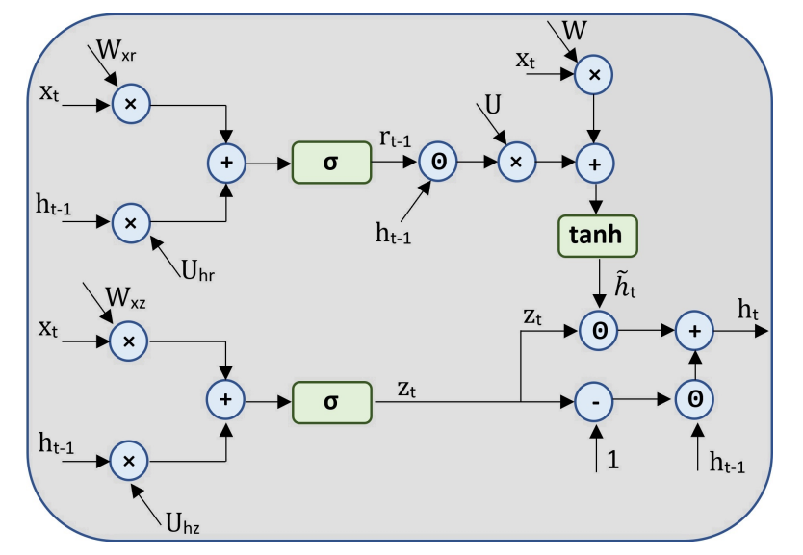
Fig. 3. Block architecture of unrolled GRU [11].

Based on the unrolled block architecture, the GRU hardware implementation is split into two modules: the gate module and the output module.
The gate module implements the reset gate, update gate, and an activation function. It consists of two Multiply-and-Accumulate (MAC) units that are summed. The summation is passed into a sigmoid activation function or tanh activation function and output. An example of the gate module can is seen in Fig. 4.
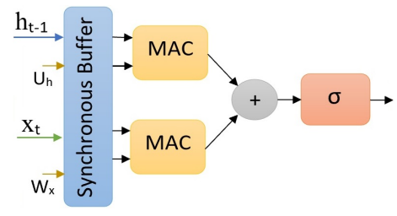
Fig. 4. GRU gate hardware implementation [11].

The output module is shown in Fig. 5. It consists of two Hadamard products and a summation, before outputting the result.
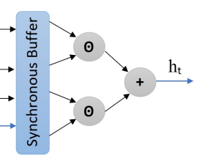
Fig. 5. GRU output hardware implementation [11].

The hardware implementation of the GRU architecture is seen in Fig. 5. It consists of three gate modules and one output module.
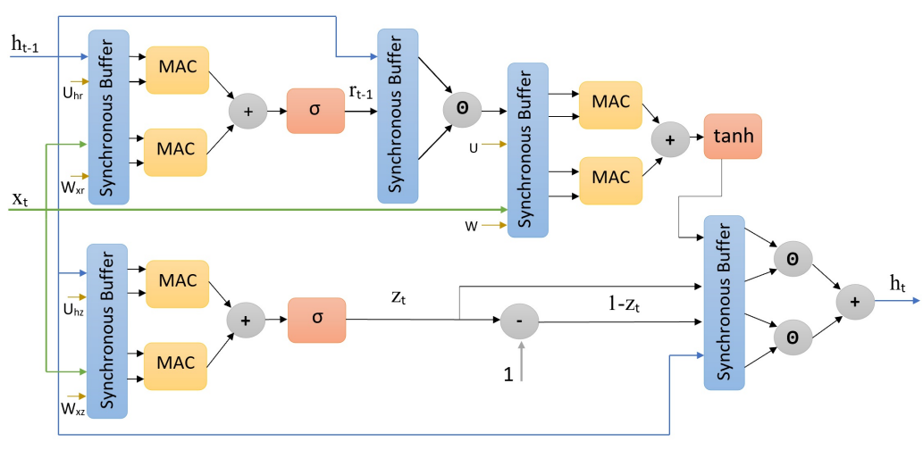
Fig. 6. Hardware implementation of the GRU architecture [11].

To implement the sigmoid activation function, Piece-Wise linear approximation (PLA) is used. There was no justification for why it was used.
$$σ\left(x\right)=\left\{\begin{aligned}0, &x≤-5 \\ 0.15625+x*0.03125, &-5<x≤2.375 \\ 0.375+x*0.125, &-2.375<x≤-1 \\ 0.5+x*0.25, &-1<x≤1 \\ 0.625+x*0.125, &1<x≤2.375 \\ 0.84375+x*0.03125, &2.375<x≤5 \\ 1, &x>5 \end{aligned}\right.$$
Due to $\tanh\left(x\right)=-1+2σ(2x)$, the following PLA can be used to estimate tanh:
$$tanh\left(x\right)=\left\{\begin{aligned}-1, &x≤-2 \\ -1+2σ(2x), &-2<x≤2 \\ 1, &x>2 \end{aligned}\right.$$
Due to all multiplication constants being powers of two, shift-and-add operations are used instead of traditional multiplication.

Optimization Techniques
Several different optimization techniques can be applied to the hardware implementation of a GRU. This section will specifically talk about using shift-and-add multiplication, bit serial structures, distributed arithmetic, mixed precision, and better implementation of the hyperbolic tangent and sigmoid functions.

Shift-And-Add Multiplication
As already shown, GRUs rely on performing many multiplications between inputs and constant weights. Since multiplication is one of the most expensive hardware operations, optimizing these weight multiplications can significantly improve efficiency. When one of the operands is constant (such as the fixed weights during deployment), generic multipliers can be replaced with shift-and-add units, which reduces hardware cost, speeds up computation, and lowers power consumption [34].
The key idea behind shift-and-add multiplication is that any multiplication can be implemented in hardware as a series of bit-shifts and additions, as long as one of the values is constant, such as a constant weight. For example, multiplying a variable $x$ by the binary constant $y=11110$ can be expressed as:
$$y*x=2^{4}x+2^{3}x+2^{2}x+2^{1}x$$
which can be achieved by only using bit shift and add operations. However, for large numbers this can result in using up to $n$ adders, where $n$ is the length of the binary constant. However, $y$ can be represented with fewer non-zero digits:
$$y=2^{5}-2^{1}=30$$
Therefore, multiplication by $y$ requires only two shifts and one subtraction instead of four shifts and three additions. This optimization using both additions and subtractions is called Canonical Signed Digit (CSD) representation. By using 1, 0, and -1 (denoted as $1, 0, \overline{1}$ respectively) to use trinary representation of numbers instead of binary, the number of nonzero digits can be reduced and multiplications can be done more efficiently.
Conversion from binary to CSD is done programmatically:
- If the binary contains at least one group of two or more 1’s:
  - From LSB to MSB, find a string of 1s followed by a 0 (such as $011$)
  - Replace the string with its CSD representation ($011$ to $10\overline{1}$)
Using shift-and-add with CSD representation provides a hardware-efficient way to perform the multiplications required by GRUs at each timestep [35-36]. As shown in Fig. 7, CSD shift-and-add multiplication is not optimal, although it outperforms binary shift-and-add multiplication. This is due to CSD only considering one type of graph topology for shift-and-add combinations. To find the most optimal solution, an exhaustive search is used to consider all possible graph topologies [36]. However, this can be difficult to perform and CSD still offers a substantial improvement over binary representation.
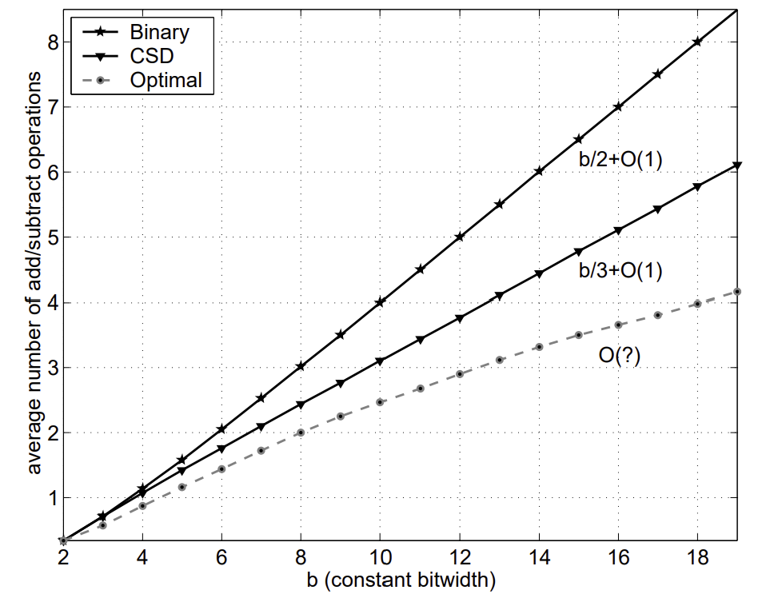
Fig. 7. Average number of add/subtract operations required for multiplying by a constant of different bit widths [36].
To perform fixed-point multiplication with shift-and-add units, given two fixed-point numbers $a$ and $b$ in $Qn1.m1$ and $Qn2.m2$ formats, respectively, the product $ab$ will be in $Qn.m$ format where $n=n1+n2$ and $m=m1+m2$. To find the product $ab$, the binary point of $a$ and $b$ are ignored, multiplication is performed, and the binary point is reinserted to the left of the $m$th bit [37].
Shift-and-add multiplication implemented via CSD can help minimize hardware resource costs by replacing multipliers with bit shifts and additions/subtractions. Due to GRUs relying on a substantial amount of multiplication operations, this hardware optimization could have a sizeable impact on hardware usage and efficiency.

Bit Serial Structures
Bit serial structures work by calculating results one bit position at a time, compared to bit parallel structures that compute results by using all bits at once. For example, to add two 32-bit integers in parallel takes 32 adders 1 clock cycle. However, using bit serial methodology 1 adder is instead used 32 times. Bit serial structures trades speed for using fewer hardware resources [38].
BCI systems typically sample in the Hz range [39], while FPGAs operate at speeds in the MHz range. This means that an FPGA can run around a million cycles between each set of new data from a BCI. To take advantage of how much faster an FPGA runs, bit serial structures can be used [40]. While they take longer to compute a result, they take up much less hardware, allowing for smaller hardware deployments. It would help keep the deployment hardware small while ensuring maximum utilization of the hardware.

Distributed Arithmetic
Distributed arithmetic is a computational operation that forms the dot product of a pair of vectors in a single step by using precomputing and is used for its high efficiency. Due to distributed arithmetic being bit-serial, it has the disadvantage of being slower than bit-parallel processing; however, as previously discussed, this is not an issue for BCI systems.
Distributed arithmetic works by precomputing specific values to help mechanize equations for faster computation. By using known restraints on functions and the properties of distribution, a small quantity of integers can be precalculated and stored to speed up equations with a much larger number of outputs [41].

Mixed Precision
Mixed precision refers to using a variety of quantization for numbers throughout a hardware deployment. The goal is to compress model size by needing less storage and hardware resources while preserving accuracy. This can be done by starting with 8 or 16-bit fixed-point numbers and reducing the number of fractional bits in places that do not degrade model accuracy, such as using 4-bit or 8-bit weights instead of full 16-bits [42].
A Gaussian optimization method has been proposed that causes less than a 1% drop in accuracy while reducing the size of a convolutional neural network by 22.66 to 28.93 times, which could be applied to GRU based networks [43].

Alternative Implementation of Sigmoid and Hyperbolic Tangent Functions
Soaryaasa et al. compared implementing the hyperbolic tangent function on an FPGA via PLA, LUTs, Range Addressable LUTs (RALUTs), Exponential Approximation with Power of Two (Power of two), and CORDIC Algorithm Approximation. It compared all methods via speed, hardware usage, and power consumption [44]. Results are shown in Table 9 and Table 10.
Table 9
Resource usage and errors of approximation methods [44]
Approximation Method | LUT  % | LUT  RAM  % | FF  % | IO  % | BUFG  % | ABS E | MSE | RMSE
PWL-3lines | 0.45 | 0 | 0.01 | 41.90 | 3.13 | 0.1482 | 0.0050 | 0.0709
PWL-5lines | 0.53 | 0 | 0.01 | 68.57 | 3.13 | 0.1057 | 0.0026 | 0.0507
LUT | 0.07 | 0 | 0.01 | 14.76 | 3.13 | 0.0012 | 1.0366e-06 | 0.0010
RALUT | 0.04 | 0 | 0.01 | 15.24 | 3.13 | 0.0278 | 0.0004429 | 0.0210
Power of two $e^{x}≅2^{1.5x}$ | 0.16 | 0.01 | 0.02 | 2.75 | 3.13 | 0.0384 | 1.5473e-04 | 0.012439
Power of two $e^{x}≅2^{1.4375x}$ | 0.16 | 0.01 | 0.02 | 2.75 | 3.13 | 0.0295 | 7.9969e-05 | 0.008942
CORDIC | 2.20 | 0.02 | 0.42 | 15.24 | 3.13 | 0.0012 | 2.1665e-06 | 0.001471

Table 10
Delay and power of approximation methods [44]
Approximation Method | WNS  (ns) | Delay  (ns) | Period  (ns) | Frequency  (MHz) | Max Frequency  (MHz) | Total Power Consumption  (W)
PWL-3lines | 5.059 | 4.941 | 10 | 100 | 202.38 | 0.142
PWL-5lines | 4.984 | 5.016 | 10 | 100 | 199 | 0.176
LUT-Flat-50 | 4.537 | 5.463 | 10 | 100 | 183.05 | 0.103
LUT-Flat-10 | 5.238 | 4.762 | 10 | 100 | 210 | 0.108
LUT-Linear-50 | 5.284 | 4.716 | 10 | 100 | 212 | 0.155
LUT-Linear-10 | 5.238 | 4.762 | 10 | 100 | 210 | 0.113
RALUT-Flat-50 | 4.537 | 5.463 | 10 | 100 | 183.5 | 0.103
RALUT-Flat-10 | 5.238 | 4.762 | 10 | 100 | 210 | 0.108
RALUT-Linear-50 | 1.844 | 10.154 | 12 | 83.33 | 98.5 | 0.113
RALUT-Linear-10 | 0.717 | 9.283 | 10 | 100 | 107.7 | 0.112
Power of two $e^{x}≅2^{1.5x}$ | 0.225 | 9.775 | 10 | 100 | 102.30 | 0.140
Power of two $e^{x}≅2^{1.4375x}$ | 0.165 | 9.835 | 10 | 100 | 101.67 | 0.140
CORDIC | 3.679 | 36.321 | 40 | 25 | 27.532 | 0.117

When looking at Table 9, the most important metrics to consider are LUT %, LUTRAM %, FF %, Abs E (analogous to MAE), and RMSE. LUT %, LUTRAM %, and FF % all give information on the hardware usage of the design, where lower is better. Abs E and RMSE give information on accuracy of the implementation, where lower is better.
When looking at Table 10, Max Frequency and Total Power Consumption are the most important metrics to consider. Max Frequency gives information on how fast the implementation can run, where higher is better, and Total Power Consumption gives information on how much power the implementation consumes, where lower is better.
Of the options analyzed, RALUT and LUT implementations have the highest max frequency and the lowest power consumption. CORDIC and LUT implementations have the lowest Abs E and RMSE. Finally, LUT and RALUT implementations have the lowest LUT %, LUTRAM %, and FF %. Thus, a LUT implementation should be used for hyperbolic tangent.

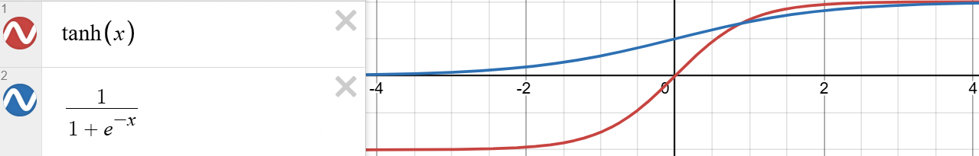
Fig. 8. Comparison of tanh and sigmoid functions
The hyperbolic tangent and sigmoid function are similar because they both have a derivative close to zero for majority of the function except for about 8 units around x=0 and being completely continuous functions. Thus, the method of using LUTs to perform a hyperbolic tangent will also work to perform the sigmoid function.

Critical Analysis and Research Gaps
This review shows the advantage of implementing GRUs on FPGAs for EEG-based BCI systems. GRUs offer a high amount of computational efficiency, while FPGAs offer reconfigurability and hardware optimizations not available to software implementations of GRUs. However, current hardware implementations of GRUs don’t take full advantage of the potential optimizations that FPGAs offer. Table 11 shows a summary of analyzed hardware optimizations that could improve hardware implemented GRUs.
Table 11
Summary of Analyzed Hardware Optimizations
Optimization | Summary
Shift-And-Add Multiplication | Replaces hardware multipliers used for constant multiplication with lower cost shift and addition/subtraction operations. This results in a more efficient hardware implementation.
Bit Serial Structures | Replaces parallel arithmetic operations done in one clock cycle with serial arithmetic operations done in multiple clock cycles. Although slower, it takes advantage of the low data rate of EEG signals to optimize hardware utilization.
Distributed Arithmetic | Replaces runtime multiplications with precomputed partial sums stored in LUTs. This enables more efficient hardware implementation while using more hardware resources.
Mixed Precision | Using variable bit-width representations for numbers enables smaller hardware implementations. It trades a small loss in accuracy for more efficient hardware implementation.
Alternative Implementation of Sigmoid and Hyperbolic Tangent Functions | Replaces PLA implementation of sigmoid and hyperbolic tangent functions with LUTs. This yields faster and more power-efficient hardware realizations of these functions.

More research should be done on the possible hardware optimizations for GRUs, especially considering that each hardware optimization will have a different effect on the power consumption, speed, and utilization of the final hardware realization. For example, while shift-and-add multiplication lowers the size of hardware implementations, also implementing bit serial structures will increase the size of hardware implementations. This would result in an unknown shift in the size of the hardware implementation. Thus, future research should be done to evaluate the impact of multiple hardware optimizations.
Furthermore, it is important to determine if power consumption, speed, or utilization is the most important factor when considering hardware optimizations for BCI systems. Given the relatively low frequency of EEG signals compared to FPGA clock speeds, maximizing computational speed may be less important than minimizing power consumption for edge or wearable deployments.
Finally, there appears to be a lack of research on implementing GRUs on FPGAs, likely due to the relative novelty of GRUs and the complexity of FPGA design and programming. Therefore, this seems to lead to FPGAs being either used for BCI signal acquisition or not at all, bottlenecking research in the field of FPGA deployment of BCI ML models.

Conclusion
This review explored the implementation of GRUs on FPGAs for BCI applications, with a focus on identifying hardware-specific optimizations that can improve efficiency, speed, and power consumption. GRUs are computationally efficient alternatives to LSTM units, offering similar performance with a simpler architecture. FPGAs provide an ideal platform for BCI GRUs that require low latency and high energy efficiency due to their reconfigurable digital logic and parallelism. Existing hardware implementations of GRUs demonstrate the feasibility of GRU deployment but leave substantial room for hardware-specific optimization.
The reviewed hardware optimization techniques, shift-and-add multiplication, bit-serial structures, distributed arithmetic, mixed precision, and improved function approximations, could each improve GRU performance. Shift-and-add multiplication using CSD representation can significantly reduce the number of required multipliers, a major source of power and area consumption. Bit-serial and distributed arithmetic structures can reduce hardware area. Mixed precision quantization provides a trade-off between accuracy and hardware area. Finally, LUT or RALUT implementations of sigmoid and tanh functions offer increased efficiency compared to traditional PLA or CORDIC approaches.
In conclusion, implementing GRUs on FPGAs represents a promising direction for advancing the efficiency, portability, and real-time performance of BCI systems. By incorporating hardware specific optimizations GRU implementations can achieve better efficiency and lower power consumption compared to current implementations.

References
- L. F. Nicolas-Alonso and J. Gomez-Gil, “Brain Computer Interfaces, a review,” Sensors, vol. 12, no. 2, pp. 1211–1279, Jan. 2012. doi:10.3390/s120201211
- J. R. Wolpaw et al., “Brain-Computer Interface Technology: A review of the first international meeting,” IEEE Transactions on Rehabilitation Engineering, vol. 8, no. 2, pp. 164–173, Jun. 2000. doi:10.1109/tre.2000.847807
- E. Haselsteiner and G. Pfurtscheller, “Using time-dependent neural networks for EEG classification,” IEEE Transactions on Rehabilitation Engineering, vol. 8, no. 4, pp. 457–463, 2000. doi:10.1109/86.895948
- M. I. Jordan, “Serial order: A parallel distributed processing approach,” Advances in Psychology, pp. 471–495, 1997. doi:10.1016/s0166-4115(97)80111-2
- Y. Bengio, P. Simard, and P. Frasconi, “Learning long-term dependencies with gradient descent is difficult,” IEEE Transactions on Neural Networks, vol. 5, no. 2, pp. 157–166, Mar. 1994. doi:10.1109/72.279181
- S. Hochreiter and J. Schmidhuber, "Long Short-Term Memory," in Neural Computation, vol. 9, no. 8, pp. 1735-1780, 15 Nov. 1997, doi: 10.1162/neco.1997.9.8.1735.
- K. Cho et al., “Learning phrase representations using RNN encoder–decoder for statistical machine translation,” Proceedings of the 2014 Conference on Empirical Methods in Natural Language Processing (EMNLP), 2014. doi:10.3115/v1/d14-1179
- AIML.com, “Sequence models compared: RNNS, lstms, Grus, and Transformers,” AIML.com, https://aiml.com/compare-the-different-sequence-models-rnn-lstm-gru-and-transformers/.
- J. Chung, C. Gulcehre, K. Cho, and Y. Bengio, Empirical Evaluation of Gated Recurrent Neural Networks on Sequence Modeling, Dec. 2014.
- Y. Gal and Z. Ghahramani, “Dropout as a Bayesian Approximation: Representing Model Uncertainty in Deep Learning,” Proceedings of The 33rd International Conference on Machine Learning, vol. 48, pp. 1050–1059, 2016.
- Z. S. Zaghloul and N. Elsayed, "The FPGA Hardware Implementation of the Gated Recurrent Unit Architecture," SoutheastCon 2021, Atlanta, GA, USA, 2021, pp. 1-5, doi: 10.1109/SoutheastCon45413.2021.9401819.
- F. Pacini, T. Pacini, G. Lai, A. M. Zocco, and L. Fanucci, “Design and evaluation of CPU-, GPU-, and FPGA-based deployment of a CNN for motor imagery classification in brain-computer interfaces,” Electronics, vol. 13, no. 9, p. 1646, Apr. 2024. doi:10.3390/electronics13091646
- Avnet Silica, “FPGA vs. GPU vs. CPU – hardware options for AI Applications | Avnet Silica,” FPGA vs. GPU vs. CPU – hardware options for AI applications, https://my.avnet.com/silica/resources/article/fpga-vs-gpu-vs-cpu-hardware-options-for-ai-applications/.
- J. Schneider, “FPGA vs. GPU for deep learning applications,” IBM, https://www.ibm.com/think/topics/fpga-vs-gpu.
- R. Wain et al., An overview of FPGAs and FPGA programming; Initial experiences at Daresbury, Nov. 2006.
- K. -K. Shyu, P. -L. Lee, M. -H. Lee, M. -H. Lin, R. -J. Lai and Y. -J. Chiu, "Development of a Low-Cost FPGA-Based SSVEP BCI Multimedia Control System," in IEEE Transactions on Biomedical Circuits and Systems, vol. 4, no. 2, pp. 125-132, April 2010, doi: 10.1109/TBCAS.2010.2042595.
- K. -K. Shyu et al., "Total Design of an FPGA-Based Brain–Computer Interface Control Hospital Bed Nursing System," in IEEE Transactions on Industrial Electronics, vol. 60, no. 7, pp. 2731-2739, July 2013, doi: 10.1109/TIE.2012.2196897.
- Z. Cai et al., “A high performance heterogeneous hardware architecture for Brain Computer Interface,” Biomedical Engineering Letters, vol. 15, no. 1, pp. 217–227, Nov. 2024. doi:10.1007/s13534-024-00438-4
- A. Güneysu and H. L. Akin, "An SSVEP based BCI to control a humanoid robot by using portable EEG device," 2013 35th Annual International Conference of the IEEE Engineering in Medicine and Biology Society (EMBC), Osaka, Japan, 2013, pp. 6905-6908, doi: 10.1109/EMBC.2013.6611145.
- I. Martišius and R. Damaševičius, “A prototype SSVEP based real time BCI gaming system,” Computational Intelligence and Neuroscience, vol. 2016, pp. 1–15, 2016. doi:10.1155/2016/3861425
- W. Chen, S.-K. Chen, Y.-H. Liu, Y.-J. Chen, and C.-S. Chen, “An electric wheelchair manipulating system using SSVEP-based BCI system,” Biosensors, vol. 12, no. 10, p. 772, Sep. 2022. doi:10.3390/bios12100772
- S. Zuo, Y. Xie, L. Wu and J. Wu, "ApaPRFL: Robust Privacy-Preserving Federated Learning Scheme Against Poisoning Adversaries for Intelligent Devices Using Edge Computing," in IEEE Transactions on Consumer Electronics, vol. 70, no. 1, pp. 725-734, Feb. 2024, doi: 10.1109/TCE.2024.3376561.
- M. Aravind and S. S. Babu, "Embedded implementation of brain computer interface using FPGA," 2016 International Conference on Emerging Technological Trends (ICETT), Kollam, India, 2016, pp. 1-5, doi: 10.1109/ICETT.2016.7873633.
- W. Wang, B. Li, and H. Wang, “A novel end-to-end network based on a bidirectional GRU and a self-attention mechanism for denoising of Electroencephalography signals,” Neuroscience, vol. 505, pp. 10–20, Nov. 2022. doi:10.1016/j.neuroscience.2022.10.006
- F. Rivas, J. E. Sierra-Garcia, and J. M. Camara, “Comparison of LSTM- and GRU-type RNN networks for attention and meditation prediction on raw EEG data from low-cost headsets,” Electronics, vol. 14, no. 4, p. 707, Feb. 2025. doi:10.3390/electronics14040707
- T. Chai and R. R. Draxler, “Root mean square error (RMSE) or mean absolute error (mae)? – arguments against avoiding RMSE in the literature,” Geoscientific Model Development, vol. 7, no. 3, pp. 1247–1250, Jun. 2014. doi:10.5194/gmd-7-1247-2014
- C. Willmott and K. Matsuura, “Advantages of the mean absolute error (mae) over the root mean square error (RMSE) in assessing average model performance,” Climate Research, vol. 30, pp. 79–82, 2005. doi:10.3354/cr030079
- R. J. Hyndman and A. B. Koehler, “Another look at measures of forecast accuracy,” International Journal of Forecasting, vol. 22, no. 4, pp. 679–688, Oct. 2006. doi:10.1016/j.ijforecast.2006.03.001
- F. Furizal et al., “Long short-term memory vs gated recurrent unit: A literature review on the performance of deep learning methods in temperature time series forecasting,” International Journal of Robotics and Control Systems, vol. 4, no. 3, pp. 1506–1526, Sep. 2024. doi:10.31763/ijrcs.v4i3.1546
- A. Zhang, Z. C. Lipton, M. Li, and A. J. Smola, Dive into Deep Learning. Cambridge, England: Cambridge University Press, 2024.
- PyTorch, “GRU,” GRU - PyTorch 2.8 documentation, https://docs.pytorch.org/docs/stable/generated/torch.nn.GRU.html.
- Turing, “What Is the Necessity of Bias in Neural Networks?,” Turing, https://www.turing.com/kb/necessity-of-bias-in-neural-networks.
- K. S. Mohammed Rizwan, S. Nikhil Gowda, S. Yashwanth and K. Anuros Thomas, "Custom Hardware Architecture for FPGA-Based Gated Recurrent Unit," 2025 IEEE 14th International Conference on Communications, Circuits and Systems (ICCCAS), Wuhan, China, 2025, pp. 81-86, doi: 10.1109/ICCCAS65806.2025.11102499.
- R. Garcia and A. Volkova, "Toward the Multiple Constant Multiplication at Minimal Hardware Cost," in IEEE Transactions on Circuits and Systems I: Regular Papers, vol. 70, no. 5, pp. 1976-1988, May 2023, doi: 10.1109/TCSI.2023.3241859.
- K. Z. Pekmestzi and P. Kalivas, “Constant number serial pipeline multipliers,” Journal of VLSI signal processing systems for signal, image and video technology, vol. 26, no. 3, pp. 361–368, Nov. 2000. doi:10.1023/a:1026507617721
- Y. Voronenko and M. Püschel, “Multiplierless multiple constant multiplication,” ACM Transactions on Algorithms, vol. 3, no. 2, p. 11, May 2007. doi:10.1145/1240233.1240234
- S. Arar, “Multiplication examples using the fixed-point representation,” All About Circuits, https://www.allaboutcircuits.com/technical-articles/multiplication-examples-using-the-fixed-point-representation/.
- S. TAKAMAEDA-YAMAZAKI, H. NAKATSUKA, Y. TANAKA, and K. KISE, “Ultrasmall: A Tiny Soft processor architecture with multi-bit serial datapaths for fpgas,” IEICE Transactions on Information and Systems, vol. E98.D, no. 12, pp. 2150–2158, 2015. doi:10.1587/transinf.2015pap0022
- S. Ajami, A. Mahnam, and V. Abootalebi, “Development of a practical high frequency brain–computer interface based on steady-state visual evoked potentials using a single channel of EEG,” Biocybernetics and Biomedical Engineering, vol. 38, no. 1, pp. 106–114, 2018. doi:10.1016/j.bbe.2017.10.004
- T. Thongkham and Y. Jewajinda, "A Low-Cost Bit-Serial Hardware Architecture and FPGA implementation of Spiking Neural Network," 2024 28th International Computer Science and Engineering Conference (ICSEC), Khon Kaen, Thailand, 2024, pp. 1-4, doi: 10.1109/ICSEC62781.2024.10770748.
- S. A. White, "Applications of distributed arithmetic to digital signal processing: a tutorial review," in IEEE ASSP Magazine, vol. 6, no. 3, pp. 4-19, July 1989, doi: 10.1109/53.29648.
- A. Shawahna, S. M. Sait, and A. El-Maleh, “FPGA-based accelerators of deep learning networks for learning and classification: A Review,” IEEE Access, vol. 7, pp. 7823–7859, 2019. doi:10.1109/access.2018.2890150
- D. T. Nguyen, H. Kim and H. -J. Lee, "Layer-Specific Optimization for Mixed Data Flow With Mixed Precision in FPGA Design for CNN-Based Object Detectors," in IEEE Transactions on Circuits and Systems for Video Technology, vol. 31, no. 6, pp. 2450-2464, June 2021, doi: 10.1109/TCSVT.2020.3020569.
- S. Sorayaasa, “Different Implementation Methods of TANH on FPGAs For Neural Networks Application,” thesis, 2022

